Solutions of ”counting problem”
Chi-Kit Pao

Table of Contents
1 Solution via matrix multiplication 1
1.1 Calculation for any number 1
2 Solution via generating function 2
2.1 Calculation for remainder of sums other than 0 3
2.2 Calculation of generating function using gcd(k, d) 3

Solution via matrix multiplication
The problem from YouTube video "Olympiad level counting - How many subsets of {1,…,2000} have a sum divisible by 5" by 3Blue1Brown (url: https://www.youtube.com/watch?v=bOXCLR3Wric) can be described via matrix multiplication.
We want to name the counts of sums congruent to (0, 1, …, d-1) modulo d (d=5 in the video) as
As per definition in video, an empty set has a sum of 0 and is a multiple of d.
If we know the counts in a set of given numbers (set C), and we’ve got another set with counts (set A), the total counts for the union (set T) of these two sets will be (e. g. d=5):
.
For example, for the count of sums congruent to 2 in the new set T, we can combine:
- sums congruent to 2 from set C and sums congruent to 0 from set A,
- sums congruent to 1 from set C and sums congruent to 1 from set A,
- sums congruent to 0 from set C and sums congruent to 2 from set A,
- sums congruent to 4 from set C and sums congruent to 3 from set A, and
- sums congruent to 3 from set C and sums congruent to 4 from set A.
In total, it will be, which is third row (t₂) from the result of matrix multiplication.

Calculation for any number
First of all, we know that for an empty set, there is one sum (= 0), so c₀ is 1 and c₁ = c₂ = c₃ = c₄ = 0.
Then we combine this set with a set with only the number “1”. We’ve got two possibilities here to:
- either don’t use the new number (congruent 0 mod 5, a₀=1), or
- or use the new number (congruent 1 mod 5, a₁=1).
So for the new set as union of empty set and number “1”, we’ve got the following new counts in a solution vector.
.
It works similarly when combining this set with number “2”:
.
For sets with 3, 4, and 5 numbers:
.
For sets with numbers n > 5, we can repeat the matrix generation and matrix multiplication with the solution vector for n=5. If there is remainder for n divided by 5, we will apply another matrix multiplication with solution vector of n=1, …, 4.

For n = 2000, we will need 2000 / 5 = 400 steps.

But we can also calculate solution vectors for n=5¹, 5², 5⁴, etc. by multiplying the generated matrix with the new solution vector coming out from the matrix multiplication.
For n = 2000 = 5 * 400 and 400 = 1 1001 0000_{b}, we need to multiply with solution vectors of 5¹⁶, 5¹²⁸, and 5²⁵⁶.

Solution via generating function
In the YouTube video "Olympiad level counting - How many subsets of {1,…,2000} have a sum divisible by 5" by 3Blue1Brown (url: https://www.youtube.com/watch?v=bOXCLR3Wric), it shows a solution by using a generating function:
.
With, the sum f(ζ⁰)+f(ζ¹)+f(ζ²)+f(ζ³)+f(ζ⁴) results in 5 times of the sum of coefficients which is multiple of 5:

For numbers n which is multiple of 5, the video gives the answer that there aresums which are divisible by 5. E. g. for n=2000, there areof them.
This approach works similarly with every divisor d ≥ 2 and when n is multiple of d.

Calculation for remainder of sums other than 0
I’ve have modified this approach by adding factors while adding the generating functions. Withand k is the remainder of sums when dividing by d (e. g. 5), the sum α_{0,k}f(ζ⁰)+α_{1,k}f(ζ¹)+α_{2,k}f(ζ²)+α_{3,k}f(ζ³)+α_{4,k}f(ζ⁴) results in 5 times of the sum of coefficients with remainders is k = (0, …, 4) when divided by 5:

For k=0, the formula remains the same since all factorsequal to 1. For k=1..4, we’ve got the formulafor number of sums with remainder k when divided by 5.
This approach works similarly with every divisor d ≥ 2 and when n is multiple of d. If n is not a multiple of d, we’ll have to apply matrix multiplication with solution vector of n=1, …, d-1 (see 1.1).

Calculation of generating function using gcd(k, d)
Given the generating function for divisor d and numbers from 1 to n (with n is a multiple of d):
, the video by 3Blue1Brown shows that when we plug infor x, with k=0, …, d-1, the function can be expressed as, since.
Let call the product . The larger d, the more terms need to be multiplied in .
However,can be calculated without actual multiplying the terms. Instead we can apply the following three rules.

Rule 1:

Rule 2: If d has 2 as factor more often than k (in other words: is even, where gcd means the greatest common divisor), then at least one of the is 0 and.
Example 1: d = 6, k = 3
Since gcd(3, 6) = 3 and 6 / 3 = 2 is even, so are and.
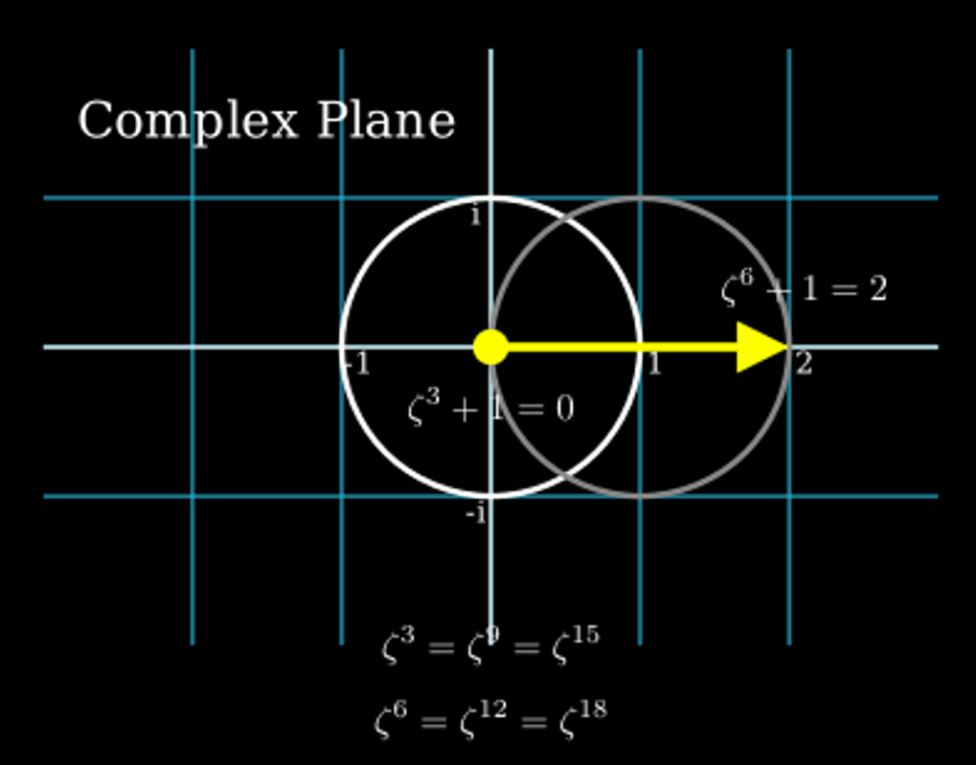
Example 2: Rules 2 can be applied if, since d/gcd(k, d) is even for k = 1, …, d-1, and so is .

Rule 3: In the remaining cases, the following applies: .
Example 3: d = 6, k = 2
Since gcd(2, 6) = 2 and 6 / 2 = 3 is not even, so is.
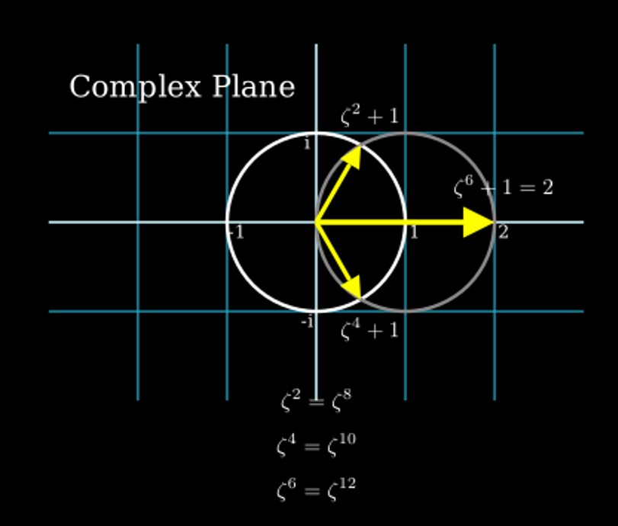
Example 4: Rules 3 can be applied if d is an odd prime number, since gcd(k, d) is 1 for k = 1, …,
d-1. So is .

